# 

# 

# 

# Case Study

**Calgary Traffic Incident Analysis**

# 

# 

# KRISH PATEL

# 000965430

**Table of Contents**

1. Introduction ....................................................................................................................................3

1. Purpose and Goals........................................................................................................................4
2. Key Questions on Dataset..........................................................................................................5
3. Metrics and KPIS...........................................................................................................................6
4. Data Model.......................................................................................................................................7
5. Results...............................................................................................................................................8

1. Power BI Dashboard.................................................................................................................11
2. Conclusions...................................................................................................................................13

* 1. **INTRODUCTION**

The dataset used in this project originates from the **City of Calgary’s Open Data Portal**, a publicly accessible resource that provides various datasets related to municipal services, infrastructure, and urban planning. This particular dataset focuses on **traffic incidents** and captures a wide range of events that may impact traffic flow and road safety.

* 1. **Dataset Overview**

The dataset contains detailed records of traffic incidents that occur within Calgary, helping researchers, city planners, and policymakers analyze urban mobility challenges. The dataset spans from December 2016 to the present, offering a rich historical perspective on traffic disruptions and trends.

## PURPOSE AND GOALS

1. **Purpose:**

The purpose of this project is to analyze traffic incident patterns in Calgary, identify high-risk locations, and evaluate incident response times. By leveraging data-driven insights, we aim to improve road safety, optimize traffic control measures, and support emergency response planning.

1. **Goals:**

* Identify peak times for traffic incidents.
* Analyze high-risk locations with frequent incidents.
* Evaluate average response times and resolution delays.
* Provide insights to improve city planning and road safety measures.
  1. **KEY QUESTIONS ON DATASET**
* **What are the most frequently occurring types of traffic incidents?**

Analyzing incident types can help authorities address common road safety concerns.

* **Which locations or quadrants have the highest number of traffic incidents?**

Identifying high-risk areas allows for targeted interventions and infrastructure improvements.

* **During which time periods do traffic incidents peak?**

Understanding daily, weekly, and monthly trends helps optimize traffic control strategies.

* **What is the overall trend in traffic incidents over time?**

Long-term trends provide insights into the effectiveness of past safety measures and policychanges.

* **On average, how long does it take to resolve a traffic incident?**

Assessing response times can help enhance emergency services and reduce delays.

* 1. **METRICS AND KPIS**

#### Total Traffic Incidents

This metric measures the overall number of reported traffic incidents over time. It helps in identifying trends, seasonal variations, and long-term patterns in road safety. Tracking this ensures informed decision-making for traffic management and infrastructure planning.

#### Peak Incident Hours

This KPI highlights the busiest times of the day for traffic disruptions, typically during rush hours. By analyzing time-based patterns, authorities can optimize traffic control measures, deploy resources efficiently, and improve road safety during high-risk periods.

#### High-Risk Locations

Mapping incident density helps pinpoint areas with frequent accidents, enabling targeted road safety interventions such as improved signage, traffic signals, or structural modifications. This ensures proactive risk mitigation and enhances commuter safety.

#### Average Response Time

This KPI tracks how quickly emergency services respond to incidents, assessing their efficiency. Faster response times reduce congestion and improve accident outcomes. Monitoring this metric helps optimize emergency resource allocation and road safety strategies.

* 1. **DATA MODEL**

#### 5.1 Overview of the Data

The dataset includes key attributes such as incident type, location, time of occurrence, and resolution status. These attributes help create meaningful insights into traffic patterns and safety measures.

**4.2 Entity-Relationship Diagram (ERD)** The ERD illustrates relationships between incidents, locations, timestamps, and resolution details, forming a structured data model for analysis.

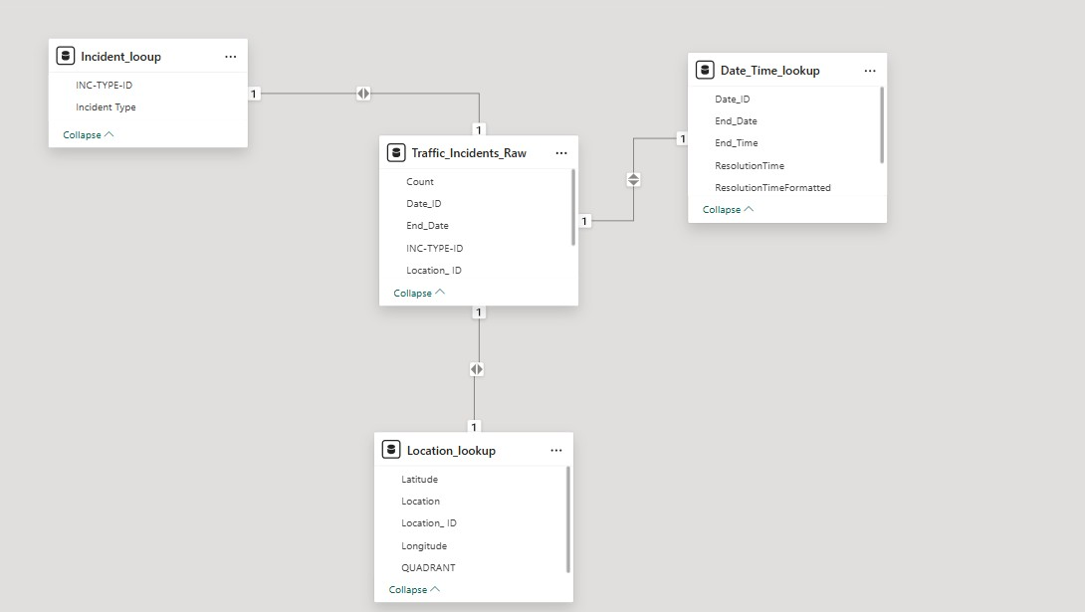

* 1. **RESULTS**

#### 6.1 Total Traffic Incidents

Card A visual representation showing the total number of traffic incidents reported over time, helping to understand overall trends and fluctuations.

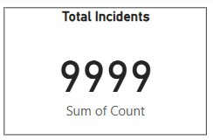

#### 6.2 Peak Incident Hours

Clustered Column chart displaying the busiest times of the day for traffic incidents, allowing for better resource allocation and planning.

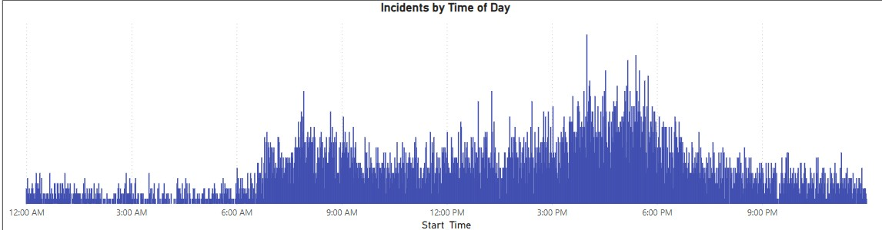

#### 6.3 High-Risk Locations

Map A geographic heatmap highlighting locations with the highest incident density, assisting in targeted safety improvements.

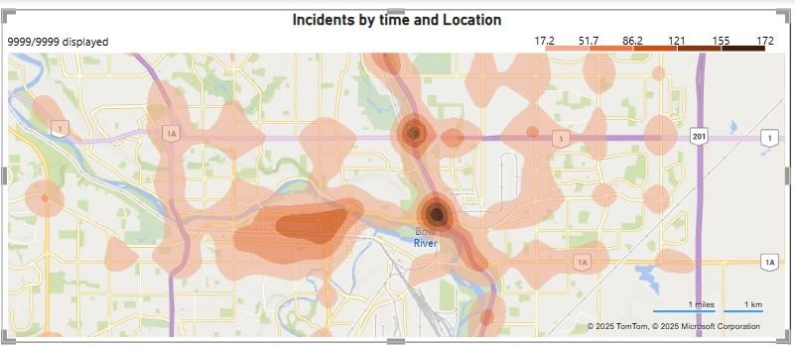

**6.4 Incident Trend Over Time**

Line Graph A line graph illustrating how traffic incidents have changed over months and years, identifying patterns and anomalies.

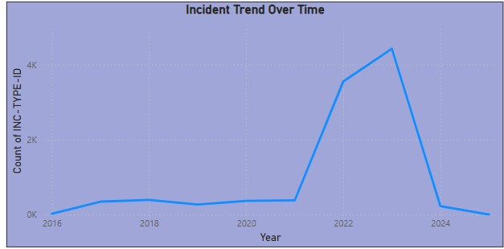

**5.5 Average Response Time :**

Clustered Column chart metric showing the average time taken to respond to and resolve traffic incidents, providing insights into emergency response efficiency.

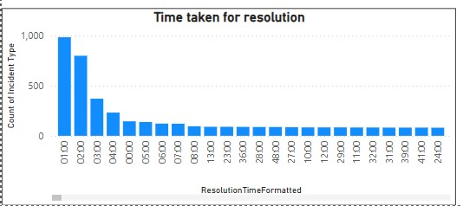

**5.6 Incident Types:**

Clustered bar chart categorizing traffic incidents by type (e.g., collisions, stalled vehicles, road hazards), highlighting common problem areas.

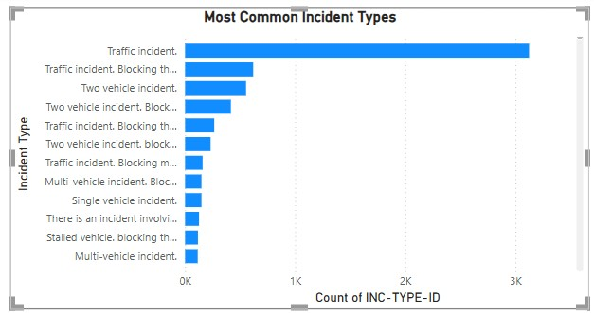

* 1. **DASHBOARD 1 : OVERVIEW OF INCIDENTS**

This dashboard provides an overall summary of **9,999 incidents**, categorized by quadrant, type, resolution time, and trend over time. The **SE quadrant** has the highest number of incidents (31.23%), while **SW has the least (19.58%)**. The **most common incident type** is a general "Traffic incident," followed by "Traffic incident blocking the road" and "Two-vehicle incidents." The **incident trend over time** shows a peak in recent years before declining in 2024. The **time taken for resolution** is also visualized, indicating that most incidents are resolved within a few hours.

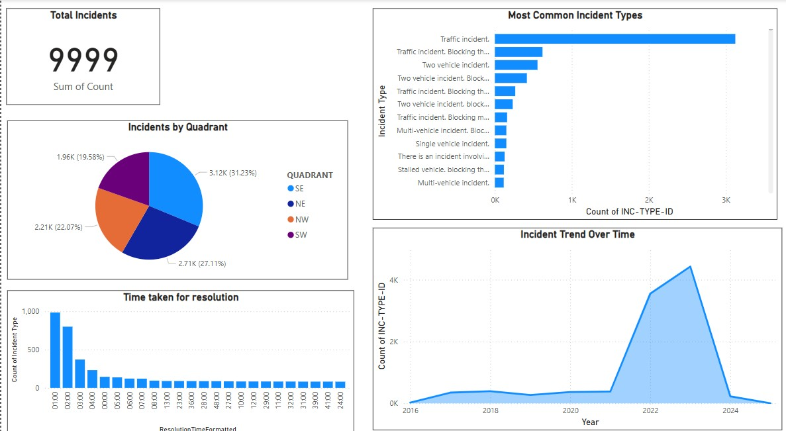

## Dashboard 2: Spatial and Temporal Analysis of Incidents

This dashboard highlights geographic **distribution, time-based patterns, and location-specific trends** of incidents. The **heatmap** identifies high-incident areas, especially near major roads and intersections. The **time-of-day analysis** reveals that incidents peak during **morning and evening rush hours**, indicating a strong correlation with traffic congestion. The quadrant-based breakdown remains consistent with the first dashboard, reinforcing the **SE quadrant as the most affected region**.

These insights provide valuable data for strategic planning and traffic management improvements.

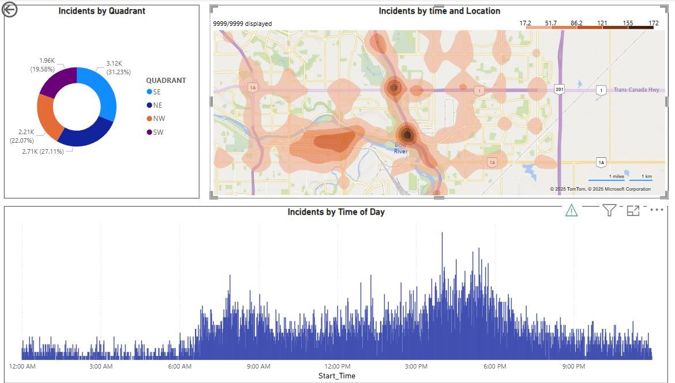

* 1. **CONCLUSION**

The analysis of Calgary's traffic incidents provides critical insights into accident trends and high-risk areas. By leveraging this data, city planners can implement targeted safety measures, improve traffic control, and enhance emergency response strategies.

.